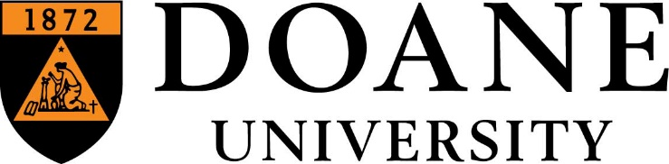

SENIOR HUMAN RESOURCES GENERALIST

Doane University in Nebraska is accepting applications for a Senior Human Resources Generalist position. The Senior HR Generalist will administer a variety of HR programs and initiatives. Responsibilities will predominantly focus on recruitment and hiring, new employee onboarding, and orientation. HRIS management, HR reporting, employee wellness program and workers compensation included. This position also assists the Director with compensation management, policy development and employee relations activities.
Qualifications/Skills/Abilities:
- 3+ years of Human Resources related experience in the areas of recruitment and hiring, employment law, compensation administration, policy development and administration, safety, HRIS management, etc.
- Knowledge of Human Resource functions, policies and procedures.
- Excellent PC knowledge, high technical aptitude and experience with a human resource information system (HRIS.) Proficient in MS Office products.
- Ability to work closely with the Information Technology department to develop reports and improve the utilization of the HRIS.
- Excellent written and verbal communication skills.
- Ability to work effectively with various constituencies; excellent interpersonal skills with the ability to develop rapport with others.
- Strong commitment to diversity, equity and inclusion.
- Ability to organize, prioritize and plan work.
- Project management skills and abilities.
- Ability to analyze and interpret HR-related data and information to form conclusions and recommendations.
Education: Bachelor's degree in Human Resource Management, Business Management or related field.
Certifications: PHR or SHRM Certification preferred, but not required
This position offers a combination of working options, including the Lincoln, NE Campus, Crete, NE Campus and remote. Primary location will be Crete, NE.
Mission Statement: Doane University creates distinctive educational experiences, rooted in the liberal arts, to prepare our students for careers and lives grounded in inquiry, ethics, and a commitment to lead and serve in the global community.
The values are our guiding principles; they are Inclusion, Integrity, Innovation and Transformation.
Doane University actively works to create and sustain a welcoming learning community for all members to fulfill their potential, belong, feel valued, and make meaningful contributions to the university. Doane University is an equal opportunity employer and seeks candidates who reflect the diversity of our society.
To apply: www.doane.edu/jobs

