Calling all HR and Business majors! Looking for an exciting internship opportunity with
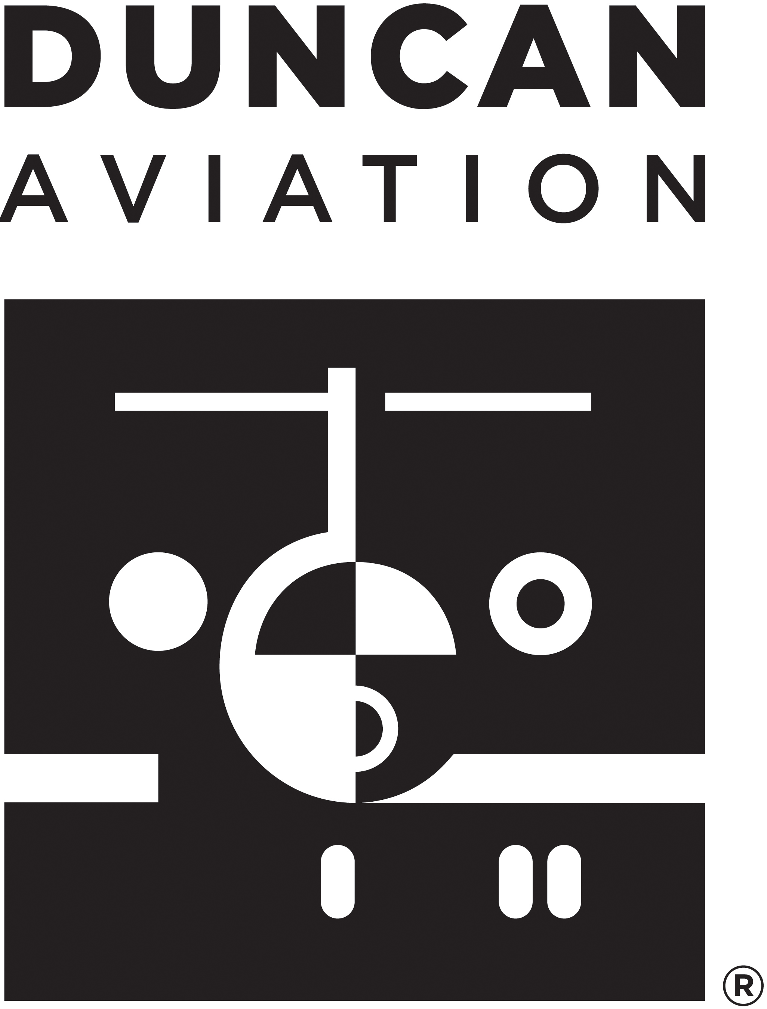
an amazing company? Look no further, Duncan Aviation has you covered!
As a Human Resources Intern, you will apply what you are learning in your
Business/HR classes while gaining practical hands-on HR experience in a corporate
setting. In this role, you'll be assigned to work on strategic projects, help support general
HR operations and learn from a team of HR professionals.
This is a PAID, year-long internship with flexible hours (between normal business hours M-F, 8-5pm) of 15-20 hours/week (more during breaks if you are up for it!).
Don’t miss out on this rare opportunity! Visit our career site and submit your application today!
Essential Job Functions
1. As a Human Resources Intern, you will be responsible for a wide variety of duties, which may include the following.
- Provides back-up support to the Administrative Assistant by greeting and assisting team members face-to-face, on the phone and via e-mail.
- Performs various data entry in the Human Resources Information System, Applicant Tracking System, and benefit carrier websites.
- Partners with the HR team on updating various team member communication resources (bulletin boards, lunchrooms, News from TMS, the Intranet and DATV.)
- May be asked to assist with participating in interviews and represent Duncan at local career hiring events.
- Performs a variety of support duties (i.e. preparing orientation materials, filing, etc.).
- Assists with team member engagement events, the United Way campaign and other community involvement activities.
- May perform other duties as assigned by the HR team and management.
Job Specific Requirements
- Licenses/Certificates: N/A
- Attendance: Regularly scheduled attendance required, intern is expected to regularly work 15-20 hours/week
- Physical: Repetitive motion; tolerates standing, walking, bending and sitting; proficient typing and data entry skills
- Environmental: N/A
- Work Schedule: Flexible based on work schedule during normal business hours M-F, 8:00am - 5:00pm
Education and Experience
- Currently a full-time student at a four-year college or university in Nebraska as junior or senior status; or currently a full-time student at a two-year college in Nebraska and successfully completed a minimum of one-half of the total credit hours required for an associate degree; or a resident of Nebraska, enrolled full-time in a four-year college or university in a state other than Nebraska, and achieved junior or senior status
- Preferred course of study in Business Administration, Human Resources, Organizational Development, Management or related field
- Proficiency with Microsoft software (Word, Excel, Power Point, etc.) required
Duncan Aviation is an Equal Opportunity and Affirmative Action Employer. EOE Minorities/Females/Protected Veterans/Disabled

