Director of People
Join our growing steel fabrication team as our first Director of People.
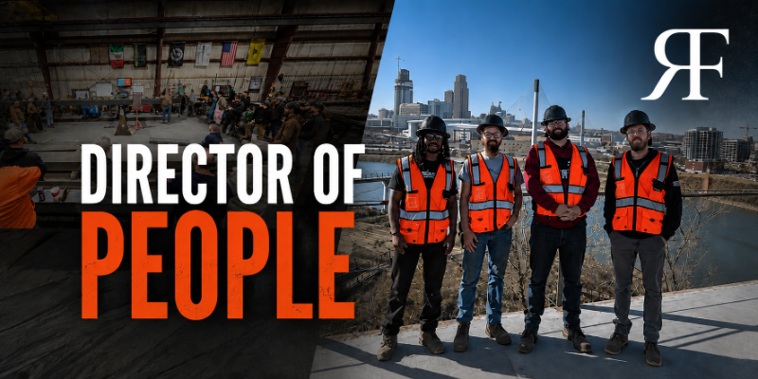
Rebellion Fabrication
Wahoo & Elkhorn, Nebraska | Full-time, on-site
Rebellion Fabrication is a structural and architectural steel fabricator and one of the region’s fastest-growing shops. We build big things for demanding clients, and we’ve grown fast by hiring great people and holding a high bar. We run on EOS. Our values are simple and we mean them: Excellence, Thrive or Die, and Teamwork.
We’ve built something rare here — a culture our people are genuinely proud of, real operating discipline through EOS, and structure already in place: defined pay ranges and advancement requirements across our shop roles, self-driven team development, and a growing benefits program. We’re not looking for someone to tear that down and start over.
We’re hiring our first Director of People to own it. As we grow, the things that got us here — strong culture carried by good people, structure that works because everyone knows everyone — need to become deliberate, consistent, and built to scale. That’s the job: understand deeply what we’ve built, protect it, seal the cracks before they widen, and mature our people systems so the culture strengthens as we grow instead of diluting.
The role
This is an ownership role. Much of the structure already exists — what it needs is an owner: someone to give it cadence, rigor, and consistency, and to build the next layer as we scale. You’ll take what we have and make it deliberate: when things get reviewed, what informs a change, who decides, how it holds together across every department and shift. You’ll also build where we have gaps. We’re looking for someone senior enough to set direction and shape philosophy, and grounded enough to own the hands-on work of making it real, reporting directly to our Integrator.
What you’ll own
- The people systems we’ve started — pay ranges and advancement paths, performance and accountability, onboarding — giving them a clear owner, a review cadence, and consistency across the shop floor and the office.
- Employee relations and accountability: personally leading sensitive employee matters — including investigations, terminations, and difficult accountability conversations — from start to finish, with sound judgment, consistency, and appropriate documentation.
- Compensation and benefits maturity: owning our benefits program and 401(k), leading our first company-wide and leadership compensation review, and building the structure for how comp is set, reviewed, and evolved.
- Team development and training: turning self-driven learning into an intentional development architecture, bringing in the right specialized training, and helping our leaders lead other leaders.
- One Rebellion culture as we grow — making sure our culture and core values stay strong and consistent across every department and shift, so growth eliminates silos instead of creating them. Not a shop culture and an office culture; one Rebellion.
- Coaching and equipping managers and supervisors to lead their teams and hold a high bar — working alongside and through them, not managing their people for them.
- Partnering directly with our Integrator on org design, leadership development, and our long-term employee-ownership path.
Who thrives here
- You build trust fast with a skilled-trades workforce and are equally credible in the shop and the conference room. You’re approachable, unflappable, and you have a sense of humor. A non-corporate environment energizes you rather than unsettles you.
- You know the difference between a culture that’s direct and human and a genuine compliance issue — and you handle each with the right speed and the right judgment.
- You start by understanding what’s already working and why people love it here — then you make it consistent and scalable. You take ownership of systems others built and improve them; a blank page isn’t what draws you, and neither is just keeping the lights on.
- You’re joining a company with a strong foundation and real momentum, and you see the opportunity clearly: own it, tighten it, and help it scale without losing its soul.
What we offer
A genuine seat at the table, the autonomy to build something from the ground up, and a leadership team that will back you. Compensation is competitive and built around the person and the scope — we’re focused on finding the right fit, and we’ll have a direct conversation about it. Benefits and details shared during the process.
Rebellion Fabrication is an equal opportunity employer. We consider all qualified applicants without regard to race, color, religion, sex, national origin, age, disability, veteran status, or any other protected characteristic.

