LincolnHR September Board Meeting Minutes
Wednesday, September 2, 2026

Present: Nichole Hall, Amy Dorenbach, Katie Welp, Amber Dingwell, Abby Freeman, Nikki Essay, Beth Hemphill, Kassee Minzel, Kelsey Blersch, Jesse Erickson, Erinn Criner, Allison Hatch

Absent: Jessica Citta, Shelby Garber, Jill Ward

Action Items:
- Allison will check the meeting room availability at the chamber for our November Strategic Planning meeting.
- Beth will send out a poll to board members for Strategic Planning meeting availability dates and times.
- Beth will continue working on the Chapter Audit which is due on September 30th.
- Erinn will get the September presentation information sent to Nikki.
- Nikki will send Beth SCC contact information and Beth will call SCC to get additional information on the parking passes.
- If you have any photos to share from the HR NE Conference, please send them to Kassee!
- Allison will let chamber membership know that LincolnHR is holding on renewing our membership.
- Allison will send TCA information as well as Take Charge classes/mock interview dates to Beth to send out via e-mail. Abby has some UNL dates to include as well.
- Nikki will e-mail Beth regarding the bounce back e-mail from a study group participant.
- Kelsey will re-forward the YPG Panel Event information to Katie and Nikki.
- Board members will put more thought into how to get members more volunteer opportunities and more involved.
- Kelsey or Abby will announce the upcoming professional clothing drive at the September meeting.

Beth Hemphill, Chapter Management Professional (CMP)
- If you have anything to be included in the e-mail blast, please e-mail it to Beth.
- Beth will not be at the September program meeting. Kelsey will be taking her place for attendee check-ins.

Amy Dorenbach, Secretary
- Abby made a motion to approve the August minutes in Dropbox. Allison seconded the motion. No board members opposed the motion.

Jill Ward, Treasurer (Absent)
- June Financials (ending balance) - $68,120.96
- Expenses: $3,095.10
  - SHRM May Basket Raffle: $950.00
  - SHRM Conference: $1,602.43
  - Program: $375.86
- Income: $1,796.09
  - Basket Raffle: $275.00
  - Study Group: $950.00
  - Membership: $450.00
- July Financials (ending balance) - $74,393.00
- Expenses: $709.67
  - Program: $343.75
  - Constant Contact: $103.50
  - Stripe Fees: $180.81
- Income: $6,981.71
  - SHRM: $765.00
  - Study Group: $4,350.00
  - Membership: $950.00
  - Meeting Sponsor: $750.00
- August Financials (ending balance) - $75,251.88
- Expenses: $3,947.35
  - Chapter Management Fees: $2,000.00
  - SHRM Conference: $868.97
  - Marketing: $704.29
- Income: $4,806.23
  - Study Group: $3,500.00
  - Meeting Sponsor: $750.00
  - Membership: $150.00
  - Job Posting: $400.00
- Please see the full financial reports in DropBox for additional details.
- Jesse made a motion to approve the June, July, and August financials; Allison seconded the motion. No board members opposed the motion.

Nichole Hall, President
- Nichole did a check-in with board members on their Strategic Plan Goals.
- Engaging Members
  - Nichole spoke with an individual at the HR NE Conference who commented on LincolnHR’s increase in social media presence. Great work Kassee!
- Nichole asked for ideas for a location and time for our next Strategic Planning meeting in November.
- Nichole would like to avoid having the meeting at the hotel due to the cost.
- Allison stated that we could hold the meeting at her office. The conference room would be free to use and it’s within walking distance of a few different restaurant options. Or, we could drive somewhere else for dinner as well.
- Allison will check conference room availability and relay the information to Beth.
- Beth will send out a poll to board members with dates and times for availability.
- Nichole stated that the Chapter Audit is due no later than September 30th. Beth is working on this.
- Nichole did a recap of the HR NE Conference
- Nichole believes overall the conference went well.
Board members discussed one session in particular that did not have a good speaker but other sessions were good.
- Jessica talked to a number of vendors and came up with a list of potential sponsors for upcoming meetings.
- Robbie told Nichole that LincolnHR had more members attend the conference than HRAM.

Jessica Citta, Past President (Absent)
- No update.

Amber Dingwell, President-Elect/SHRM Foundation/Government Relations
- No update.

Katie Welp, Membership
- Current Members: 268
- Katie is preparing to send postcards to 199 members at large in October. Thanks for the list SHRM!
- Peyton shared with Katie that there were 5+ people at the State Conference that wanted information on LincolnHR and Katie will reach out to them.
- Katie discussed the 2027 price increase to $175.00 and how we will communicate that out.
- Katie will make an announcement at the September meeting regarding the price increase. Allison suggested including something along the lines of after a thoughtful review, LincolnHR needs to increase the price.
- Beth will write a message for the newsletter regarding the price increase as well.

Shelby Garber (Absent) & Erinn Criner, Programs
- September 2026
- Topic: From Costs to Connection: How 2027 Employee Benefit Trends Are Shaping Cost and Employee Engagement
- Speaker: Megan Septak & Sandy Ryan w/HUB International Great Plains
- Location: SCC Continuing Ed Building
- Sponsor: Relentless Merch
- Catering: Chipotle
- Note: Erinn will get the presentation sent to Nikki. She’s not sure if she has it yet but if not, she will reach out to the speaker.
- October 2026
- Topic: HR Brain Trust (facilitated networking)
- Speaker: Sarah Collins
- Location: SCC Continuing Ed Building
- Sponsor: Ameritas – Kyle Hilger & Sarah McManaman
- Catering: TBD
- Note: Professional Clothing Drive; Kelsey is working on this. Erinn believes this meeting will be an inner-generational knowledge sharing information event.
- November 2026
- Topic: Legal Update
- Speaker: Cline Williams
- Location: SCC Continuing Ed Building
- Sponsor: TBD
- Catering: TBD
- SCC Parking
- SCC is now requiring parking passes for attendees. These are free but are required to be displayed in every car at each meeting. The board believes this policy is in effect now.
- Erinn believes this may have always been a policy but one that was never managed in the past.
- Beth will call SCC to get additional information. Nikki will send Beth contact information to an individual at SCC.
Kassee Minzel/Jesse Erickson, Marketing/Social Media
- Kassee posted the final September program reminder this morning. Please give it some social media love if you’d like!
- Kassee shared a few LinkedIn Analytics after our HR NE Paid Promotional Posts:
- 27 new followers in the last 30 days.
- Between July 31st and August 29th
  - 68 pages views – up 28.3%
  - 40 unique visitors – up 37.9%
  - 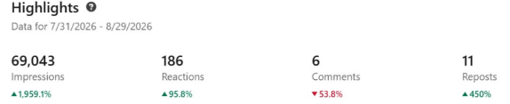
- Kassee provided additional information to learn what page views, unique visitors and impressions are actually looking at and how they are calculated.

- 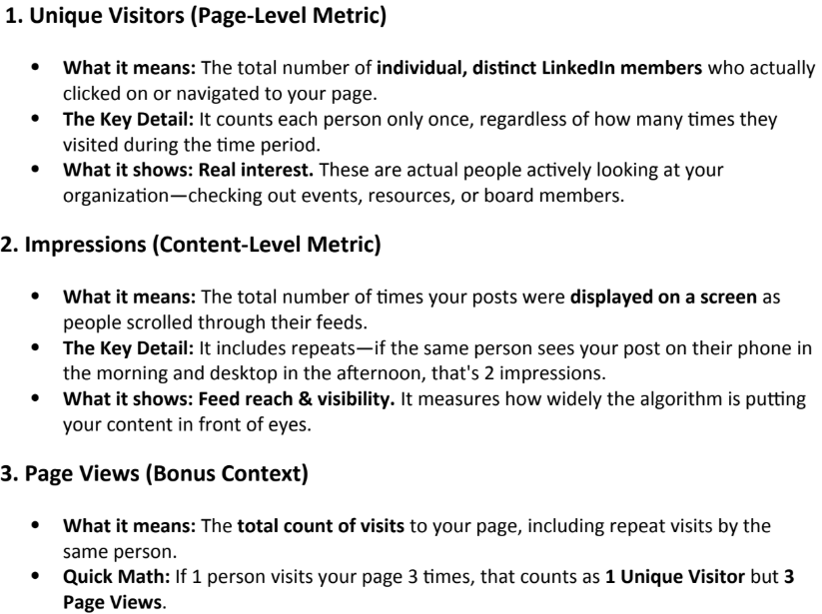
- Kassee will be doing a HR NE Recap Post – Please send her any photos you have from the conference if you would like them featured in a post!
- Nichole reminded board members that LincolnHR will receive reimbursement from HR NE for social media posts marketing the HR NE Conference.
- Jesse is continuing to coordinate LincolnHR promotional materials.
- Jesse has been working with Amber and Katie to get postcards ordered hopefully by the end of the week.
- Nichole let board members know that Jesse put together the flyers that were used at the HR NE Conference for LincolnHR.

Allison Hatch, Workforce Readiness
- Allison and Nichole discussed LincolnHR’s Chamber of Commerce membership that is currently expired. In the past, the chamber and LincolnHR have done a trade in membership but last year we paid for the membership and this year, that is no longer an option. The cost for a Chamber of Commerce membership is approximately $300-$400.
- Allison stated that if the chamber has programming over a meal, there’s an additional fee for that program. It is not included in the membership cost like LincolnHR’s.
- Things that are included in a chamber membership include: Chamber coffees, government affairs position, Chamber U (Chamber 101, which an individual would only attend once), ribbon cuttings, and networking events at The Hive or LNK.
- Items that are an additional cost would include the Toolbox Series which are events that feature professional topics but are not all HR related. They do feature a variety of interesting people.
- Abby asked if LincolnHR not being a member, would affect us working with YPG and Allison was unsure on this.
- Allison will circle back to the chamber membership and let them know that LincolnHR is currently holding on renewing our membership. LincolnHR will circle back if needed.
- Allison discussed the upcoming event with TCA on October 14th. She will create 1/2 page cards with information to be available at our next meeting. Allison will also send Beth a message with information to be e-mailed out.
- Allison reached out to LPS about Take Charge classes and all future mock interview dates. She will also include this information for Beth to e-mail out. Abby has a few dates to include for UNL as well.
- Kassee will also post this information on social media.

Nikki Essay, Certification
- Nikki stated that the study group registration is closed and we have 12 registrants!
- One of the registrants, Nikki is getting a bounce back e-mail from. Nikki will send Beth an e-mail regarding this.
- Nikki stated that the study systems have been ordered, the room is secured, and parking passes are printed.
- Nikki let all participants know that if they live in Lincoln, in-person attendance is required. Three of the participants live outside of Lincoln.
- Nikki discussed potentially looking for a new location for 2027 as SCC is now requiring a parking permit. More information to come on this. For now, we will continue with SCC unless there are a number of complaints that arise.
- Nikki let board members know that SCC has an optional $25 technology fee. This fee is for all of the study group sessions. We don’t believe that we will need to utilize this but can pivot and pay the additional fee, if needed. Currently, we pay $275 to rent the room from SCC for all of the study group sessions, this does not include the technology fee.

Kelsey Blersch, Community Outreach/Diversity
- Kelsey stated that she is still looking for volunteers for the YPG panel event on the morning of September 22nd.
- Amber, Katie, and Nichole can assist. Nikki may be able to but it is the same day as the UNL career fair. Abby and Allison are not available. Kelsey will re-forward the event information to Katie and Nikki.
- Kelsey will continue working on the Professional Clothing Drive at the October meeting.
- Amber questioned if there’s a better way to communicate with members regarding opportunities to volunteer and get involved versus asking board members.
- Kelsey stated that in this case, due to the quick turnaround time, she didn’t reach out further than board members.
- Beth stated that she is happy to send out e-mails to members for these types of volunteer events.
- Board members also suggested asking for volunteers at the coffee chats or at program meetings.
- Board members will put more thought into this and discuss more if any ideas come up.

Abby Freeman, College Relations
- Abby stated that she participated in the MyTern Event in August. It was good to be present, but it didn’t convert to people signing up. But, she believes this is something to consider going to once a year if the program continues. Perhaps next year we could provide a prize for the drawing.
- Abby stated that the UNL Research Opportunity was sent out and thanked everyone for their help. UNL plans to post on LinkedIn near the end of this week.
- Kelsey or Abby will announce the professional clothing drive at the September meeting.

Upcoming Events & Important Dates
N/A

Meeting adjourned at 12:40 p.m. The next board meeting is scheduled for Wednesday, October 7, 2026, from 11:30 a.m. to 1 p.m. The meeting will be held at Assurity Life Insurance Company; 2000 Q Street, Lincoln, NE 68503.

ald

